MICROFINANCE CREDIT RISK SCORING PLATFORM
ABSTRACT:-
The Microfinance Credit Risk Assessment Platform is a data-driven system designed to evaluate borrower reliability and minimize credit risk for microfinance institutions. It integrates multiple data sources—including borrower demographics, loan details, transactions, and field visit insights—to predict the likelihood of default. The project aims to automate decision-making, enhance financial transparency, and reduce human bias through predictive analytics. By visualizing complex risk patterns via interactive dashboards, the platform empowers lenders to make faster, evidence-based decisions while improving financial inclusion for underserved communities.

INTRODUCTION:-
Microfinance institutions (MFIs) are pivotal in driving financial inclusion, particularly in rural and semi-urban areas where access to traditional banking remains limited. These institutions offer small loans to individuals and micro-entrepreneurs who lack formal credit histories, enabling them to build sustainable livelihoods. However, the rapid expansion of microfinance lending has brought with it several challenges — primarily the issue of credit risk management.
Credit risk, the possibility that a borrower will fail to meet repayment obligations, is one of the most critical factors affecting the sustainability of microfinance institutions. Many MFIs still rely on manual assessment methods, personal judgments, and outdated data to make credit decisions, which often results in inaccurate risk evaluation, higher default rates, and operational inefficiencies.
The Microfinance Credit Risk Assessment Platform aims to address these challenges by adopting a data-centric approach to lending decisions. By integrating borrower demographics, income data, loan performance, field visit observations, and digital transaction records, this platform provides a comprehensive and automated risk assessment model. Python-based analytics help visualize trends, identify high-risk borrowers, and forecast repayment capabilities. Meanwhile, interactive dashboards enhance transparency and enable real-time monitoring of borrower behavior.
This project bridges the gap between financial accessibility and data intelligence — ensuring credit decisions are both inclusive and analytically sound.

OBJECTIVES:-
The main objectives of this project are:
1. To develop a unified credit risk assessment model using borrower, loan, and transaction data.
2. To visualize and interpret borrower trends through Python-based dashboards.
3. To reduce default probability by identifying risky borrower patterns early.
4. To enable real-time loan monitoring using data analytics.
5. To enhance decision-making accuracy for microfinance institutions through automated insights.

SCOPE:-
This project focuses on analyzing financial and behavioral data of borrowers in microfinance institutions. It can be extended to:
- Predict borrower performance and repayment capability.
- Integrate real-time updates from field visits and telecom usage.
- Support financial officers through interactive visual dashboards.
- Scale to larger credit networks and NGO-based microfinance programs.

1.Literature Review
Microfinance institutions play a major role in providing loans to people who do not have access to traditional banking services. These borrowers often belong to rural and low-income communities and do not have formal credit history. Because of this, evaluating their repayment ability becomes challenging. Therefore, microfinance organizations are now using data analytics to assess credit risk more accurately.
1.1 Traditional Microfinance Lending Practices
Earlier, loan officers used manual methods to decide whether a borrower could repay the loan. They mainly relied on:
- Personal interviews
- Basic income declaration
- Household information
- Trust and relationship-based judgement
However, this traditional approach had several limitations:
- Judgement varied from officer to officer (not standardized)
- No recorded financial history to verify repayment ability
- High chance of loan defaults due to inaccurate risk assessment
So, decisions were less data-driven and more experience-based, which sometimes led to financial losses for lenders.

1.2 Modern Data-Driven Risk Assessment
With the growth of digital payments, banking apps, and mobile usage, new types of borrower data have become available. Modern microfinance systems now analyze:
- Transaction behavior (frequency, spending pattern, saving capacity)
- Telecom usage (mobile recharge & data usage as economic activity signals)
- Field visit business health scores
- Location-based economic conditions
These factors provide a more realistic picture of the borrower’s financial behavior.
Data analytics tools like Python and SQL help in cleaning, combining, and analyzing this data to identify patterns related to repayment capacity.
1.3 Use of Dashboards for Decision-Making
Visualization tools such as Power BI allow microfinance institutions to:
- Monitor high-risk borrowers
- Compare repayments across regions
- Track loan distribution trends
- Quickly identify customers needing follow-up support
This makes loan decisions faster, fair, and unbiased, reducing chances of default.
1.4 Research Gap
Although large microfinance companies use advanced credit scoring models, many small and semi-urban lending institutions still:
- Rely on manual verification
- Do not use transaction and telecom data
- Lack automated borrower scoring systems
- This creates a gap in fair assessment and risk prediction.
This Project Addresses the Gap By:
- Integrating multiple datasets (borrowers, transactions, telecom, field visits, geolocation)
- Analyzing behavior patterns using Python & SQL
- Classifying borrowers into Low, Medium, and High risk
- Presenting insights through Power BI dashboards for easy decision-making
BACKGROUND OF THE DATASETS
The Microfinance Credit Risk Assessment Platform utilizes multiple datasets that collectively create a comprehensive view of borrower reliability.
1. Borrowers Dataset: Contains borrower_id, name, age, gender, education level, income, and location. Name is used only for identity, while borrower_id is used for analysis.
2. Loans Dataset: Contains details such as loan amount, tenure duration, interest rate, loan status, and default label. Used to study repayment patterns and default trends.
3. Field Visits Dataset: Contains business_health_score and income_change based on in-person assessments by field officers, reflecting real business stability.
4. Transactions Dataset: Records financial transactions (credit/debit) and channels used, helping evaluate cash flow consistency.
5. Telecom Data Dataset: Contains sim_count, topup_freq, data usage, and device change frequency — behavioral indicators useful where formal financial history is limited.
6. Geolocation Dataset: Includes district-level average income, rural/urban classification, and rainfall patterns, indicating environmental and livelihood context.
Together, these datasets create a 360-degree borrower profile, improving the accuracy of credit risk scoring and supporting financial inclusion.

2.DATASET DISCRIPTION
1.borrowers.csv
borrower_id | name | age | gender | income | education | location
1 | Aryan Maharaj | 22 | Female | 22592 | Secondary | Rajahmundry
2 | Harsh Chahal | 29 | Male | 37256 | Primary | Patna
3 | Girik Kamdar | 23 | Male | 63302 | Primary | Dibrugarh
4 | Rushil Saini | 35 | Male | 36657 | Secondary | Sultan Pur majra
This dataset provides demographic and socio-economic details of borrowers such as age, gender, income level, education, and location. It helps in understanding how personal background influences borrowing capacity and repayment behavior.
2.field_visits.csv
borrower_id | visit_date | business_health_score | income_change
4803 | 30/10/2024 | 0.8 | 0.17
3500 | 17/12/2024 | 0.12 | -0.43
3185 | 23/03/2025 | 0.81 | -0.44
4930 | 31/07/2025 | 0.94 | 0.15

This dataset provides demographic and socio-economic details of borrowers such as age, gender, income level, education, and location. It helps in understanding how personal background influences borrowing capacity and repayment behavior.
3.geolocation.csv
district | rural_urban_flag | avg_income_district | rainfall_mm
Raichur | Urban | 17885 | 668
Jammu | Urban | 17198 | 910
Chennai | Rural | 16795 | 1984
Arrah | Rural | 58975 | 787

It captures district-level rural/urban classification, average income, and rainfall data that influence external economic conditions affecting borrowers. This helps assess risk related to geographic and environmental factors.
4.loans.csv
loan_id | borrower_id | loan_amount | tenure_months | interest_rate | status | default_label
1 | 2703 | 60598.28 | 24 | 11.05 | Active | 1
2 | 4875 | 82494.71 | 24 | 10.62 | Active | 0
3 | 4533 | 75268.93 | 18 | 12.16 | Active | 0
4 | 120 | 172705.3 | 12 | 17.25 | Closed | 1

This dataset holds loan disbursement and repayment details, including loan amount, tenure, interest rate, and default status. It is used to analyze lending patterns and identify high-risk borrower groups.

5.telecom_data.csv
Borrower_id | sim_count | topup_freq | data_usage_mb | device_changes
1 | 1 | 14 | 1099 | 5
2 | 3 | 12 | 2036 | 3
3 | 1 | 24 | 466 | 2
4 | 3 | 7 | 361 | 0
It provides digital behavioral signals such as SIM usage, recharge frequency, and device changes. These indicators act as alternative predictors of borrower stability where traditional records are limited.
6.transactions.csv
borrower_id | date | amount | txn_type | channel
415 | 22-11-2024 | 4041.08 | credit | UPI
1820 | 13-11-2023 | 2943.86 | credit | UPI
952 | 20-09-2025 | 6004 | debit | UPI
4027 | 04-01-2025 | 1586.27 | debit | BankTransfer

This dataset tracks financial transaction activities including credits, debits, and payment channels. It helps evaluate cash flow discipline and repayment capability of borrowers.

3.SYSTEM ARCHITECTURE
The Microfinance Credit Risk Assessment Platform follows a layered architecture to ensure efficient data processing, accurate risk evaluation, and meaningful visualization for actionable decision-making. Each layer performs a specific function and together they create a seamless analytical workflow.

3.1. Data Layer
This layer forms the foundation of the system by collecting and organizing data from multiple sources.
Functions:
- Import borrower, loan, transaction, telecom, geolocation, and field-visit datasets.
- Remove duplicates, handle missing values, and format date/numeric fields.
- Standardize attributes to maintain uniformity during analysis.
Outcome:
A clean and structured dataset ready for analytical processing.

3.2 Processing & Feature Engineering Layer
In this layer, raw data is transformed into meaningful insights by extracting patterns and constructing new variables.
Key Operations:
- Merge datasets using borrower_id to create a unified borrower profile.
- Compute behavior-based features such as:
- Transaction frequency & consistency
- Field visit business-health score trend
- Telecom-based financial stability indicators
- Loan repayment patterns & credit utilization
- Encode categorical features and normalize numerical attributes.
Outcome:
A comprehensive feature set that improves the quality of risk scoring.

3.3 Risk Assessment & Analysis Layer
This is the intelligence layer where risk scoring and evaluation are performed.
Tasks Performed:
- Analyze default trends and loan performance using SQL queries.
- Apply statistical and rule-based scoring techniques to evaluate borrower reliability.
Identify high-risk borrowers based on key indicators such as:
- High credit utilization
- Negative income change
- Poor field-visit ratings
- Repeated delays/overdue repayments
Outcome:
Borrowers are categorized into Low-Risk, Medium-Risk, and High-Risk groups.

3.4 Visualization & Dashboard Layer
This layer focuses on presenting insights clearly to decision-makers.
Tools Used: Python Visualizations (Matplotlib/Plotly) and Power BI Dashboards
Displays:
- Loan distribution overview
- Default vs Non-default comparison
- Top 10 high-risk borrowers
- Average income vs repayment capacity
- Field visit business performance scores
- Geographical risk distribution
Outcome:
Loan officers and analysts can make evidence-based lending decisions quickly.

System Workflow Diagram (Text Format)
Borrower+Loan +Field Visit +Telecom +Transaction + Geolocation Data
↓
Data Cleaning
↓
Feature Engineering & Merging
↓
Risk Scoring & Borrower Categorization
↓
Python Graphs + Power BI Dashboards for Analysis

4.METHODOLOGY
This project follows a structured step-by-step workflow to analyze borrower risk and classify them into Low, Medium, and High risk categories.
Step 1: Data Cleaning and Preparation
We first prepared the raw datasets collected from different sources such as borrower records, loan history, transactions, field visits, telecom usage, and geolocation.
Tasks performed:
- Removed duplicate and incorrect entries
- Handled missing values in income, scores, and loan details
- Standardized formats (date formats, categorical labels)
- This ensured that all datasets became clean, consistent, and ready for analysis.
Step 2: Organizing the Skills
We broke down skills like a list:
“Python, SQL, Machine Learning” → [Python] [SQL] [Machine Learning]
We also linked similar skills:
“Deep Learning” → counted as AI-related skill
So nothing important gets missed.

Step 3: Data Integration (Merging Datasets using borrowers_id in python and sql )
All datasets were linked using borrower_id as the common key.
Merged data included:
- Personal demographics
- Financial transactions
- Loan performance
- Telecom activity
- Field visit business stability
- Regional economic conditions
This combined dataset provided a 360-degree profile of each borrower.

Step 4: Feature Engineering (Creating New Indicators)
To assess borrower behaviour more accurately, we derived new meaningful features:
- Transaction consistency → frequency & amount stability
- Telecom activity → top-up regularity & data usage
- Business health trend → field visit score pattern
- Regional risk factor → rural/urban + average district income
These features helped reveal hidden risk patterns not visible through basic demographics.

Step 5: Risk Pattern Analysis
Python visualizations were used to identify borrower behavior trends, including:
- Default vs. non-default borrower characteristics
- Income vs. loan burden comparison
- Location-based repayment differences
- Borrower spending vs. saving patterns
This step helped understand what kind of borrowers are more likely to default.

Step 6: Loan Risk Classification
Borrowers were categorized into Low, Medium, and High risk based on:
- Loan repayment status
- Field visit business assessment
- Transaction stability
- Interest rate burden
This classification makes it easier for Microfinance Officers to prioritize follow-ups and lending decisions.

Step 7: Dashboards and Visualization
Power BI dashboards were created to visually represent:
- High-risk borrowers across regions
- Loan repayment performance trends
- Borrower credit behavior insights
- Field visit score impact on risk levels
This allows faster and evidence-based decision making.

Final Outcome:-
The methodology ensures that:
1. Borrower risk is evaluated fairly and transparently
2. Credit decisions are based on data, not guesswork
3. Microfinance institutions can reduce default rates and support genuine borrowers

5.PYTHON IMPLEMENTATION
The Python implementation played a key role in analyzing the datasets and identifying borrower risk patterns. The following steps highlight how Python was used in the project:
Step 1: Importing Required Libraries
We used Python libraries for data handling, visualization, and analytical processing:
The following Python libraries played a major role in implementation:

Library | Description
Pandas | Used for reading, cleaning, and processing the dataset.
NumPy | Provided support for mathematical and vector operations.
colorcet | .To apply visually effective and color-blind friendly color palettes
Matplotlib / Seaborn | Used to visualize trends and relationships in the data.
plotly | To create interactive charts and dashboards
These libraries helped enhance the clarity and analytical depth of the visual outputs.
import pandas as pd
import numpy as np
import matplotlib.pyplot as plt
import seaborn as sns
import plotly.express as px
import colorcet as cc
Step 2: Loading the Datasets
The datasets such as borrowers.csv, loans.csv, transactions.csv, field_visits.csv, telecom_data.csv, and geolocation.csv were loaded using Pandas DataFrames:
borrowers = pd.read_csv("borrowers.csv")
loans = pd.read_csv("loans.csv")
transactions = pd.read_csv("transactions.csv")
field_visits = pd.read_csv("field_visits.csv")
telecom = pd.read_csv("telecom_data.csv")
geo = pd.read_csv("geolocation.csv")
Tables were inspected using:
borrowers.head()
loans.head()
Tables were inspected using:
borrowers.head() loans.head()
This helped to understand the structure and data quality

Step 3: Data Cleaning & Preprocessing(EDA analysis)
Duplicate rows were removed
Missing values handled (e.g., income, business score)
Data types standardized (e.g., converting date columns)
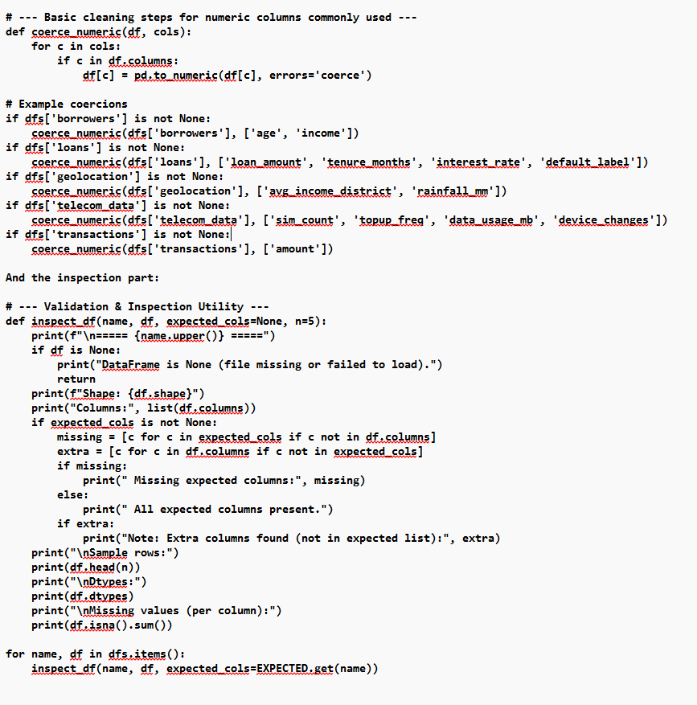

Outputs:-
1.borrowers.csv
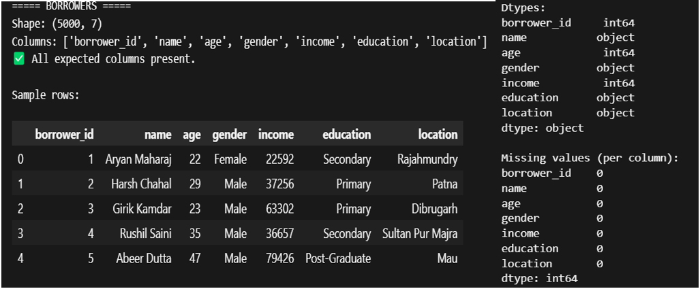
2.field_visists.csv

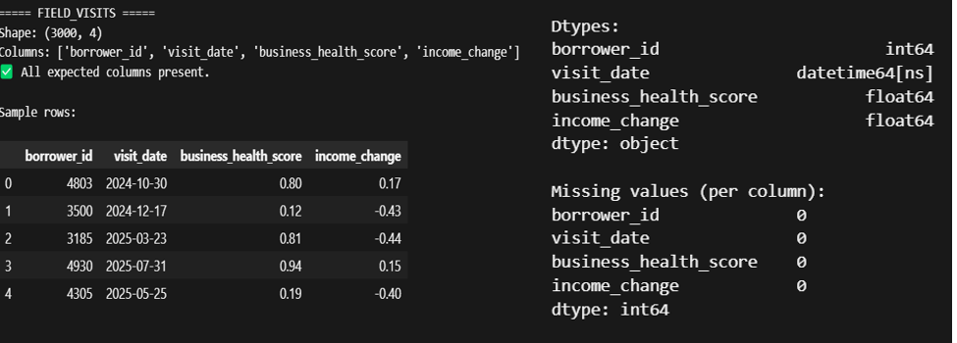
3.geolocation.csv

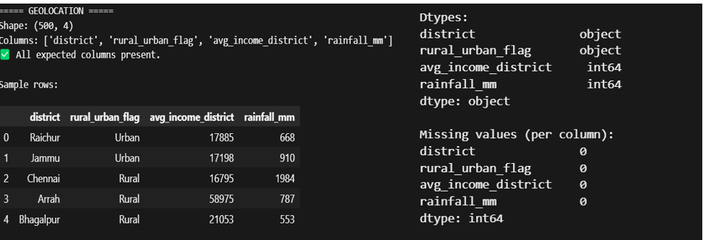

4.loans.csv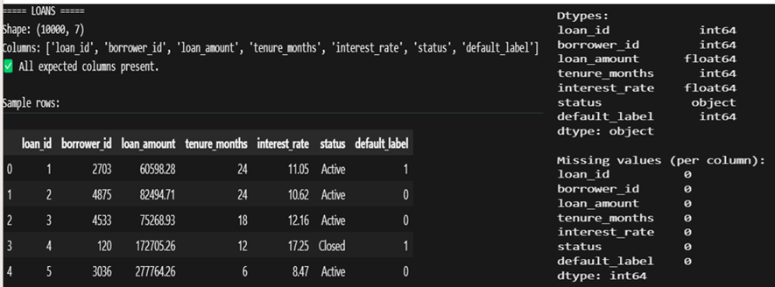

5.telecom.csv
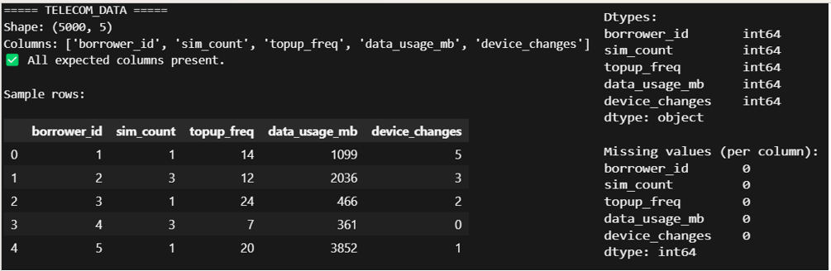
6.transactions.csv
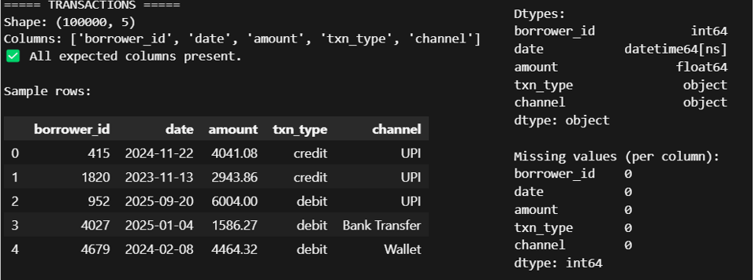Step 4: Data Integration (Merging)

# --- Example join (small sample) ---
# Join borrowers with loans (one-to-many loans) to create borrower-loan table
if dfs.get('borrowers') is not None and dfs.get('loans') is not None:
bl = dfs['loans'].merge(dfs['borrowers'], on='borrower_id', how='left', suffixes=('_loan', '_borrower'))
print("\nSample merged loans + borrowers (first 5 rows):")
try:
from IPython.display import display
display(bl.head())
except Exception:
print(bl.head())
# Example: join telecom usage aggregated by borrower
if dfs.get('telecom_data') is not None:
telecom_agg = dfs['telecom_data'].groupby('borrower_id', as_index=False).agg({
'sim_count': 'max',
'topup_freq': 'mean',
'data_usage_mb': 'sum',
'device_changes': 'sum'
}).sort_values('borrower_id').reset_index(drop=True)
print("\nTelecom aggregated sample:")
try:
from IPython.display import display
display(telecom_agg.head())
except Exception:
print(telecom_agg.head())
This created the final master dataset used for visualizations and insights.
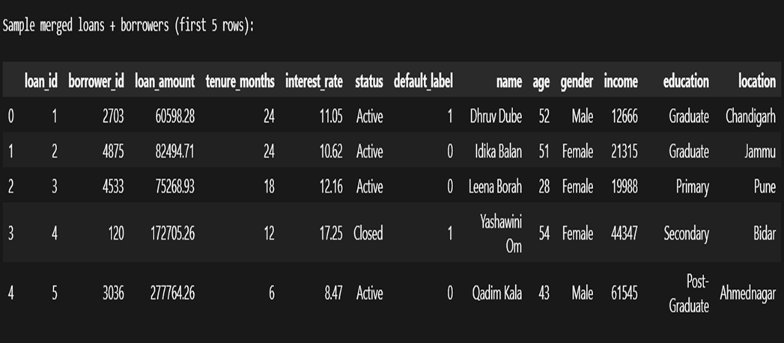
Output:-
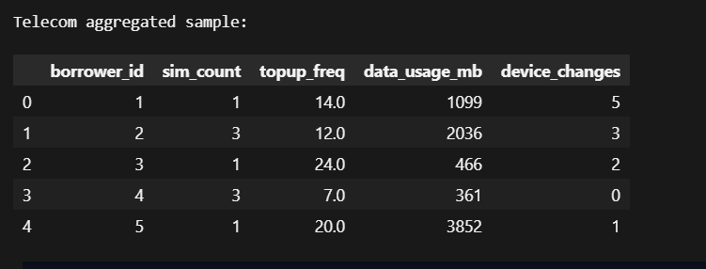
step 5: visualization(graph + tables)
created multiple graphs to observe important financial and behavioral patterns,both static and interactive graphs were created and tables for a each graph using its syntax
fig = go.Figure(data=[go.Table(
header=dict(values=[], fill_color='', align=''),
cells=dict(values=[], fill=dict(color=''), align='')
)])
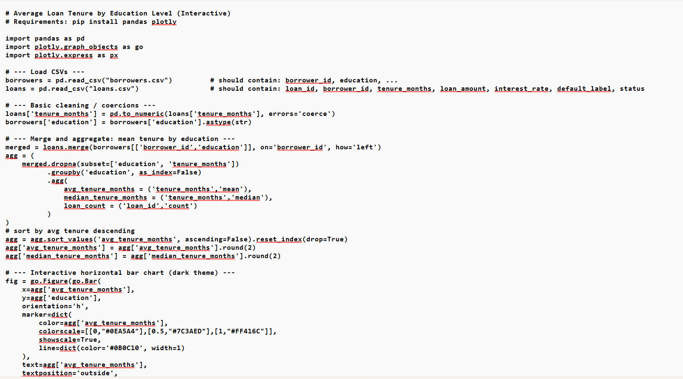
6.1Average loan tenure by education level
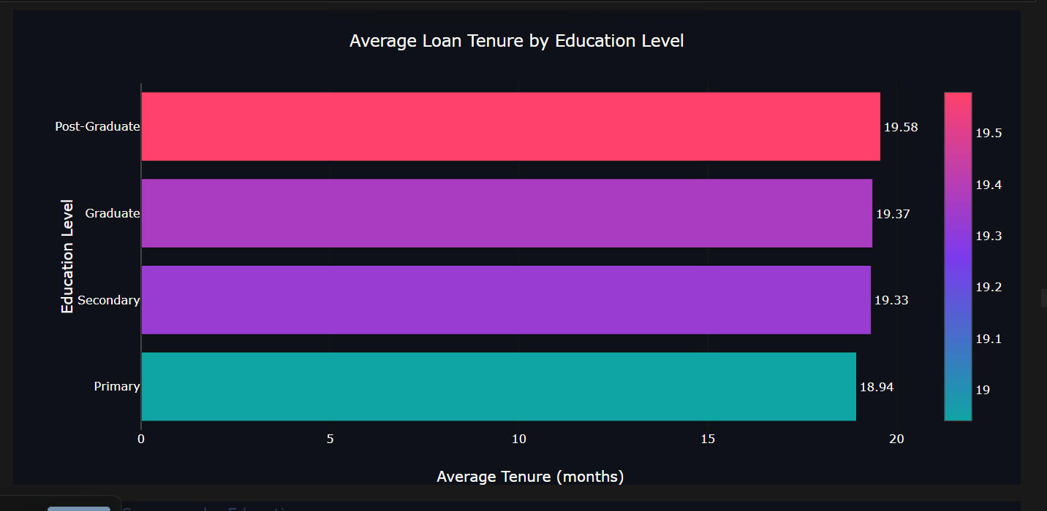
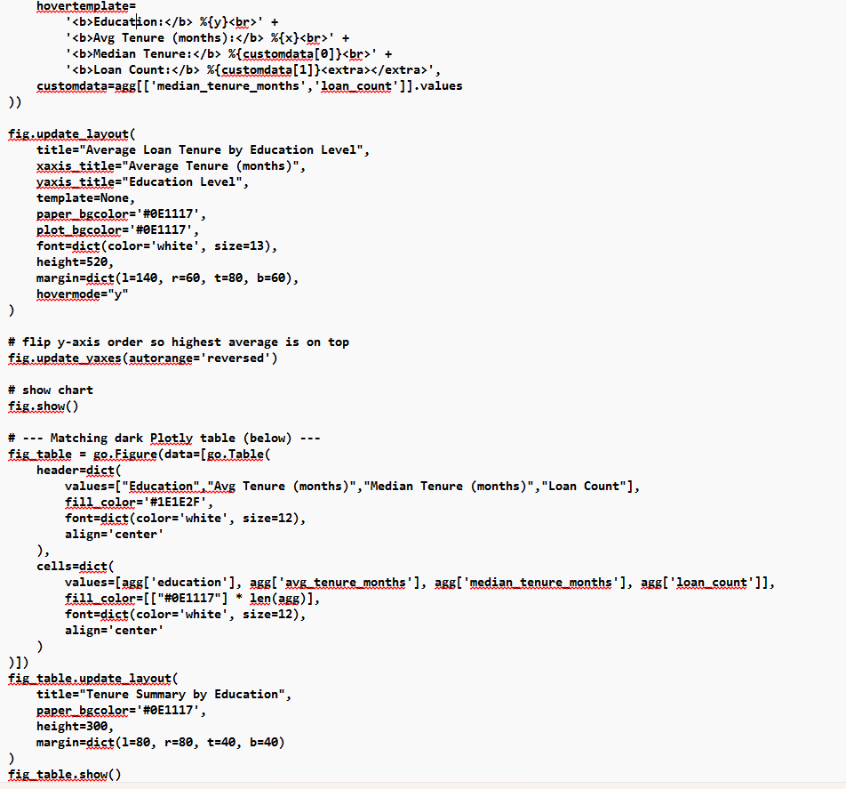

Average Loan Tenure by Education Level
The chart shows that borrowers with higher education levels tend to take loans for slightly longer durations. Post-Graduate borrowers have the highest average loan tenure (≈19.58 months), followed by Graduate and Secondary educated borrowers. Borrowers with Primary education have the lowest average tenure (≈18.94 months).
This suggests that individuals with better educational backgrounds are generally more confident in managing longer repayment cycles, possibly due to greater income stability and better financial planning.
6.1.1 table
Average Loan Tenure by Education Level(tenure summary by education)

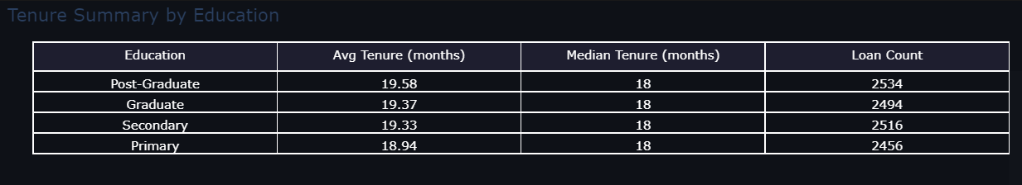
The chart shows that borrowers with higher education levels tend to take loans for slightly longer durations. Post-Graduate borrowers have the highest average loan tenure (≈19.58 months), followed by Graduate and Secondary educated borrowers. Borrowers with Primary education have the lowest average tenure (≈18.94 months).
This suggests that individuals with better educational backgrounds are generally more confident in managing longer repayment cycles, possibly due to greater income stability and better financial planning.
table shows the average and median loan tenure across different education levels. While the median tenure remains constant at 18 months for all borrower groups, there are slight variations in the average loan duration. Borrowers with higher education levels, such as Post-Graduates and Graduates, tend to receive loans with a slightly longer repayment period (around 19.58 to 19.37 months). This suggests that microfinance institutions may have greater confidence in the repayment capacity of more educated borrowers, allowing them longer time to repay.
On the other hand, individuals with Primary education have the lowest average tenure (18.94 months), indicating stricter or more cautious lending terms for borrowers with limited educational background. The loan counts across all groups are nearly the same, suggesting that education level does not significantly affect loan access, but it influences the repayment duration for which credit is offered.
6.2 Gender distribution for borrowers
import pandas as pd
import matplotlib.pyplot as plt
# Load data
borrowers = pd.read_csv("borrowers.csv")
gender_counts =borrowers['gender'].fillna('Unknown').value_counts().reset_index()
gender_counts.columns = ['Gender', 'Count']
# Plot
plt.style.use("dark_background")
fig, ax = plt.subplots(figsize=(8,6))
color_map = {'Male': '#6A0DAD', 'Female': '#2E7D32'}
bar_colors = [color_map.get(g, '#555555') for g in gender_counts['Gender']]
ax.bar(gender_counts['Gender'], gender_counts['Count'], color=bar_colors)
ax.set_title("Gender Distribution of Borrowers", color='#4FC3F7')
ax.set_xlabel("Gender")
ax.set_ylabel("Number of Borrowers", color='#4FC3F7')
plt.show()
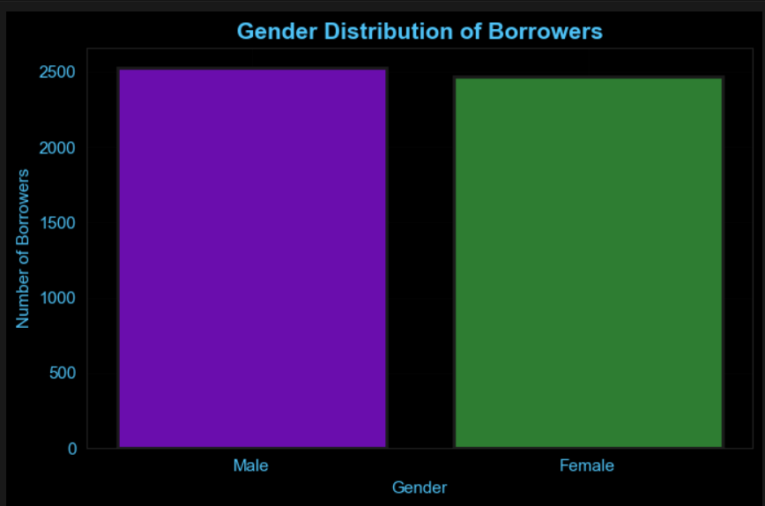
The visualization compares the number of male and female borrowers in the microfinance dataset. The results show that both genders participate actively in microfinance borrowing, with male borrowers slightly higher (2532) compared to female borrowers (2468). The difference is not very large, indicating that microfinance lending is reaching both men and women almost equally. This reflects the inclusiveness of microfinance institutions in extending credit to diverse demographic groups. However, the strong presence of female borrowers also aligns with microfinance objectives, as women are often targeted to promote entrepreneurship, household income support, and financial empowerment. Overall, the distribution suggests a balanced lending outreach, contributing to economic support across gender segments.
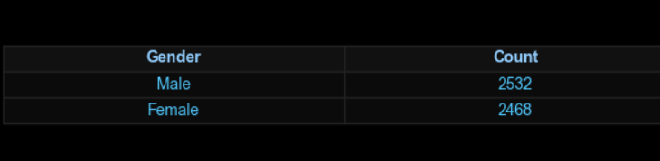
The accompanying table provides the exact counts of borrowers by gender. Male borrowers account for 2532 entries, while female borrowers total 2468 entries. The close values reinforce that loan access is fairly gender-balanced, supporting both male-led and female-led income activities.

6.3 default loans vs non-default loans
summary = df['default_label'].map({
0:'Non-Default',1:'Default'}).value_counts().reset_index()
summary.columns = ['Status','Count']

fig = go.Figure(data=[go.Pie(labels=summary['Status'], values=summary['Count'], hole=0.45,
marker=dict(colors=['#8B0000','#444444'], line=dict(color='#000000', width=2)),
hoverinfo='label+percent')])
fig.update_layout(title="Default vs Non-Default Loans", paper_bgcolor='#000000',
plot_bgcolor='#000000', font=dict(color='#E6E6E6'))
The donut chart illustrates the proportion of borrowers who have repaid their loans versus those who defaulted. Out of the total loans:

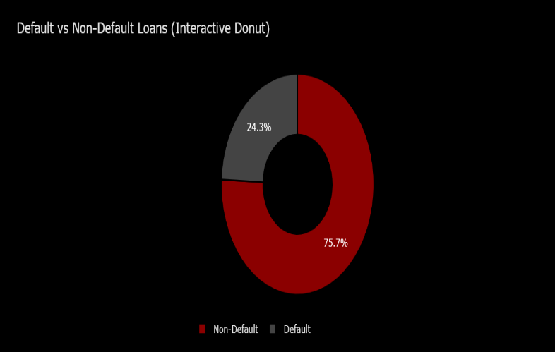
Status Count
Non-Default 7569
Default 2431

Approximately 75.7% of the loans are successfully repaid, while 24.3% have resulted in default.
This indicates that a majority of borrowers are able to manage repayment, which reflects positively on the lending operations.
However, the default rate of about one-fourth is still considerable, suggesting the need for:
• Stronger borrower screening
• Ongoing monitoring of high-risk clients
• Early intervention for borrowers showing repayment stress
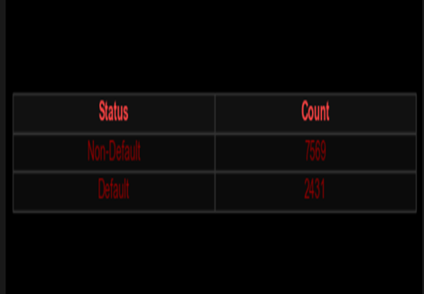
Such improved risk assessment strategies are essential to reduce future defaults and ensure financial sustainability of the microfinance institution.
Most borrowers (75.7%) are able to repay their loans, while 24.3% default. Although repayment performance is generally strong, the default ratio indicates a need for better borrower risk evaluation and monitoring.
6.4 loan status breakdown
status_counts = loans['status'].fillna('Unknown').value_counts().reset_index()
status_counts.columns = ['Status', 'Count']
wedges, texts, autotexts = ax0.pie(
status_counts['Count'],
labels=status_counts['Status'],
autopct='%1.1f%%',
colors=['#8E24AA', '#BA68C8', '#4A148C']
)
ax0.set_title("Loan Status Breakdown (Active vs Closed)")

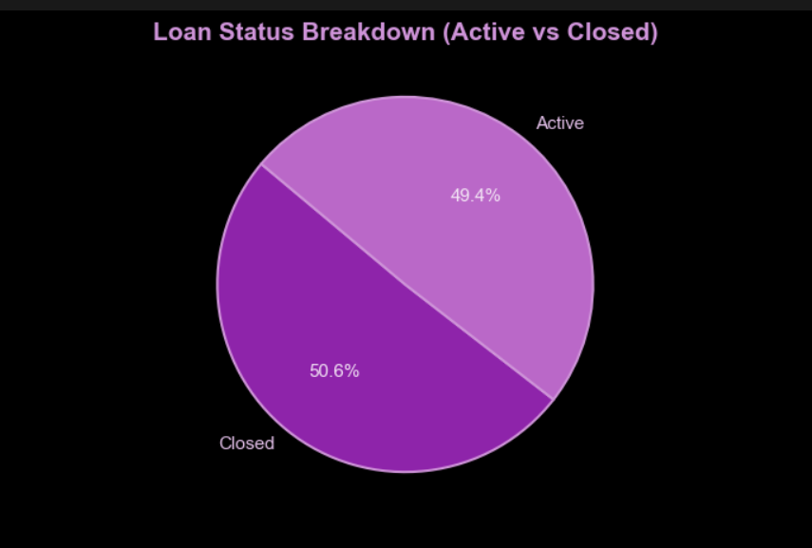


The pie chart shows the proportion of loans that are currently Active versus those that have been Closed. Based on the data:
Status Count
Closed 5060
Active 4940
50.6% of the loans have been Closed, meaning the borrowers have completed repayment.
49.4% of the loans are still Active, meaning borrowers are currently in the repayment period.
This indicates that the loan portfolio is fairly balanced, with nearly half of borrowers still repaying their loans and the other half having successfully completed repayment.
The microfinance institution shows a healthy repayment cycle, where the number of closed loans and active loans are almost equal. This balance suggests stable lending operations and a consistent loan recovery flow.
6.5 Income distribution by education level
Borrowers with higher education levels generally show better income stability, with Post-Graduate and Primary groups exhibiting higher income clusters. Meanwhile, Secondary educated borrowers reflect lower earnings, indicating possible limited employment or business opportunities.
fig = px.box(
borrowers,
x="education",
y="income",
color="education",
color_discrete_sequence=["#4A148C","#7B1FA2","#AB47BC","#CE93D8","#E1BEE7"],
title="Income Distribution by Education Level",
template="dark_violet",
points="all"
)
fig.update_traces(marker=dict(size=6, opacity=0.7, line=dict(width=1, color="#E0E0E0")), boxmean=True)
fig.update_layout(title_font_size=18, title_font_color="#BA68C8", font=dict(size=12), showlegend=False)

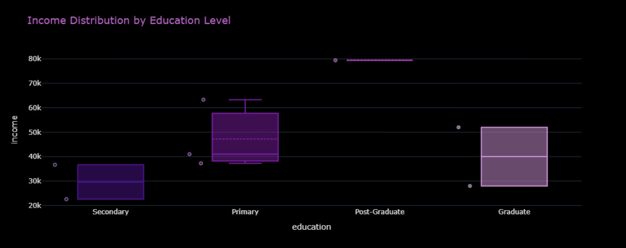
The box plot shows how borrower income varies across different education levels. Borrowers with Post-Graduate and Primary education tend to have higher average incomes, while Secondary educated borrowers show the lowest income range.
The table supports this trend — Primary level borrowers have a mean income of around ₹47,186, while Secondary borrowers average about ₹29,624. The Post-Graduate group shows a higher maximum income, but the sample size is smaller
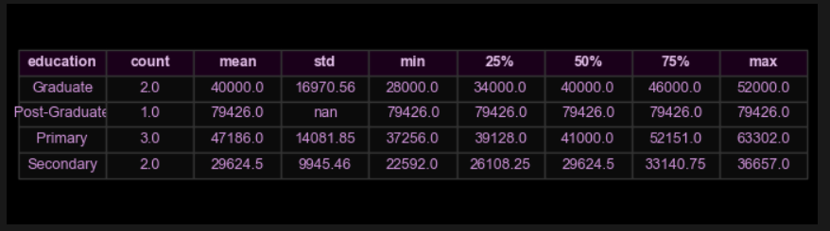 The table summarizes key statistical values for income across different education levels. Borrowers with Post-Graduate education show the highest income values (mean ~79,426), indicating better earning potential. Primary educated borrowers have moderate income levels (mean ~47,186), while Secondary educated borrowers have the lowest income range (mean ~29,624). The Graduate group lies in the middle with a mean income of ~40,000.
This suggests that higher education is associated with higher earning capacity, which may influence repayment ability and loan risk.
Higher education levels correspond to higher average incomes. Borrowers with Post-Graduate and Graduate backgrounds generally have stronger earning potential compared to those with only Primary or Secondary education.
6.6 Average customer credit profile
Borrowers are generally young with moderate income and short credit histories. Their average credit utilization remains controlled, but careful tracking is needed to prevent high-risk usage patterns.
fig = go.Figure()
fig.add_trace(go.Scatterpolar(
r=normalized.values,
theta=cols,
fill="toself",
name="Average Profile",
line=dict(color="#00FFFF", width=3),
fillcolor="rgba(157,0,255,0.4)",
marker=dict(size=8, color="#FF66B2")
))
fig.update_layout(
title="Average Customer Credit Profile (Radar Chart)",
polar=dict(
bgcolor="#0E1117",
radialaxis=dict(visible=True),
angularaxis=dict(linewidth=1)
)
)
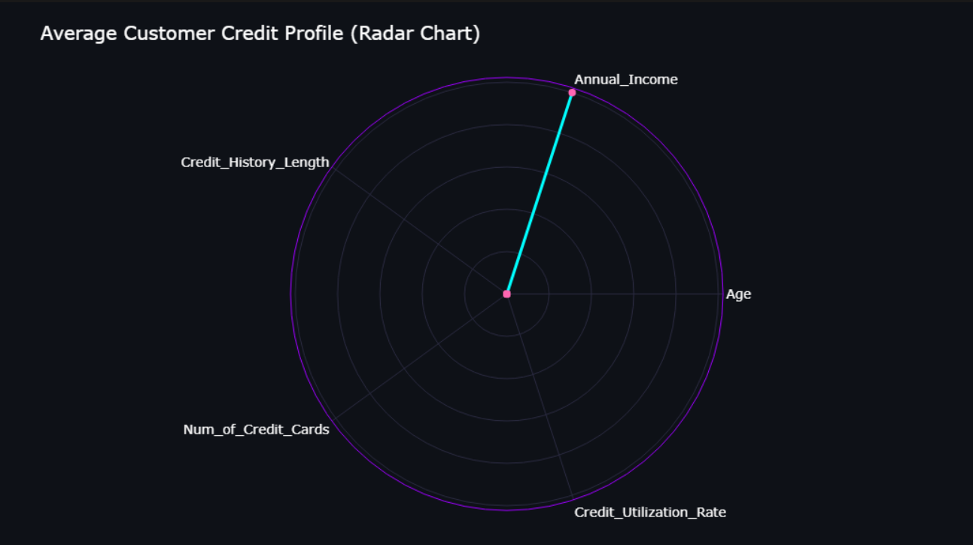
The radar chart visualizes the typical credit profile of borrowers by comparing multiple attributes on a common scale. The chart shows that Annual Income has the highest magnitude, indicating strong variation among borrowers' earnings. Age, number of credit cards, and credit history length have comparatively lower values, suggesting that most borrowers are young, have limited credit exposure, and shorter financial histories. This highlights that many borrowers are still early in their financial lifecycle, which is common in microfinance segments.
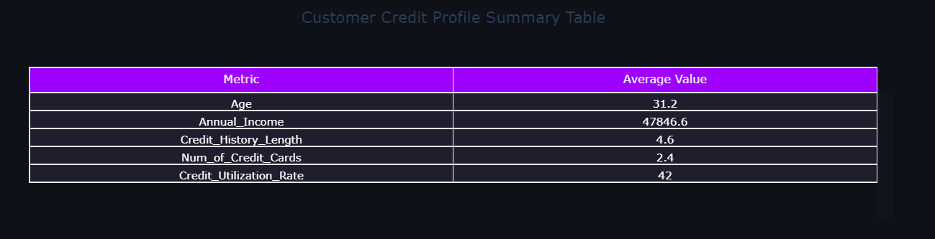
The table indicates that the average borrower is around 31 years old with an annual income of approximately ₹47,846, suggesting modest earning capacity. The credit history length of about 4.6 years shows that borrowers have limited but developing credit backgrounds. On average, borrowers hold around 2–3 credit cards, with a credit utilization rate of 42%, which is moderate. These values suggest responsible credit usage, but also indicate the need for careful monitoring, especially for borrowers with rising utilization levels.
6.7 monthly transaction volume type
The transaction trends reflect varying financial stability across months. Higher debit volumes during certain periods may indicate increased business expenses or personal consumption, which can be important indicators for assessing borrower repayment capability.
Bar Chart
for ttype, subset in monthly_txn.groupby('txn_type'):
ax0.bar(subset['month'], subset['amount'], label=ttype.capitalize(),
color=colors[ttype], edgecolor='#FFAB40', linewidth=1.5, alpha=0.9)
ax0.set_title("Monthly Transaction Volume by Type", fontsize=15, color='#FF7043')
ax0.set_xlabel("Month")
ax0.set_ylabel("Total Amount", color='#FFB74D')
ax0.legend(facecolor='#000000', labelcolor='#FFB74D', edgecolor='#333')
plt.setp(ax0.get_xticklabels(), rotation=45, ha='right')

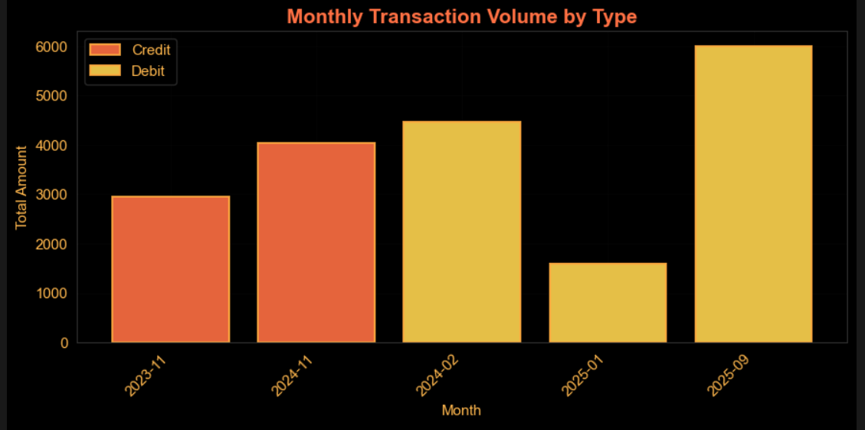
The bar chart displays the total credit and debit transaction amounts across different months. From the visualization, we observe that:
- Debit transactions are generally higher than credit transactions, especially in months like 2025-09 and 2024-11, indicating higher spending or cash outflow during these periods.

- Credit transactions (money coming into accounts) appear moderate, with noticeable inflows in 2023-11 and 2024-11, suggesting occasional income peaks.
- The month 2025-01 shows significantly low transaction volume, which could indicate reduced business activity or limited cash flow during that time.
This trend helps identify seasonal financial behavior and periods where borrowers may require closer monitoring or financial support.
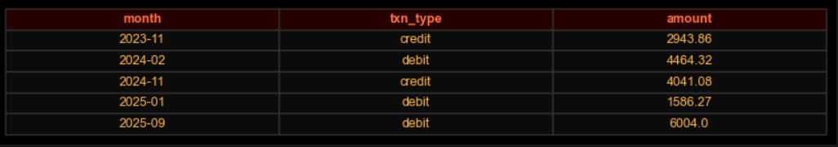
The highest transaction amount is observed in 2025-09 (Debit: 6004.00), pointing to a large outgoing payment.
The lowest recorded activity is in 2025-01 (Debit: 1586.27), suggesting reduced financial movement.
Credit inflows peak in 2024-11, while 2024-02 and 2025-09 show substantial expenditure levels.
6.8 top 10 loans – loan amount vs Interest rate
Higher loan amounts combined with higher interest rates show a greater chance of default. Moderate loan sizes appear more manageable for borrowers, leading to better repayment performance.
fig = go.Figure()
fig.add_trace(go.Bar(
x=top_df['loan_amount'],
y=top_df['interest_rate'],
marker=dict(color=top_df['loan_amount'], colorscale='Plasma')))
fig.update_layout(
title="Top 10 Loans – Loan Amount vs Interest Rate",
xaxis_title="Loan Amount",
yaxis_title="Interest Rate (%)",
paper_bgcolor='#0E1117',
plot_bgcolor='#0E1117'
)
fig_table = go.Figure(data=[go.Table(
header=dict(values=list(top_df.columns)),
cells=dict(values=[top_df[col] for col in top_df.columns])
)])
fig_table.update_layout(
title="Top 10 Loans by Amount",
paper_bgcolor='#0E1117'
)
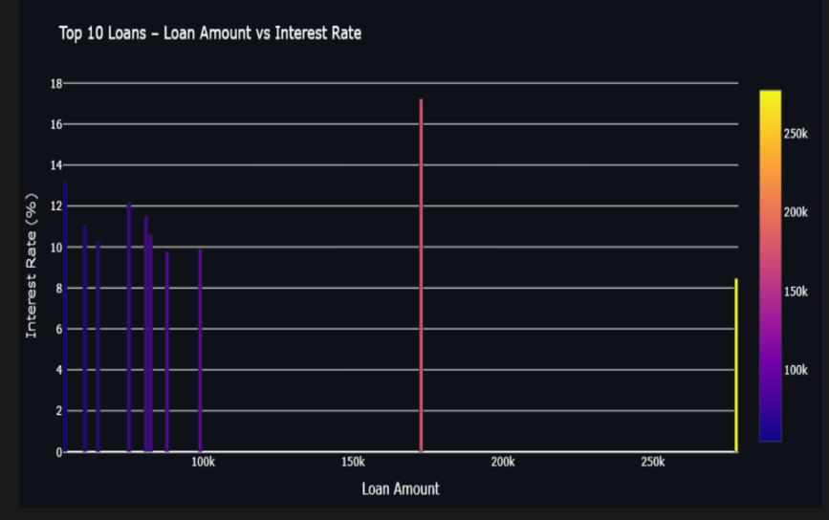
The scatter plot compares the loan amount with the interest rate for the top 10 highest loan amounts. From the visualization, we can observe that:
Larger loan amounts generally tend to have higher interest rates, indicating that microfinance institutions charge more interest when the financial risk is higher.
For example, the highest loan amount (~ ₹172,705) is associated with one of the highest interest rates (17.25%), and this loan has defaulted, showing strong linkage between high loan size + high interest burden → higher default probability.
Loans with moderate amounts (₹60,000 – ₹1,00,000 range) show medium interest rates (~9% to 12%), and many of these loans remain active without default, suggesting better repayment feasibility in this range.
This analysis suggests that microfinance institutions should carefully evaluate repayment capacity before issuing high-value loans, as increasing interest rates further raises financial stress and default risk.
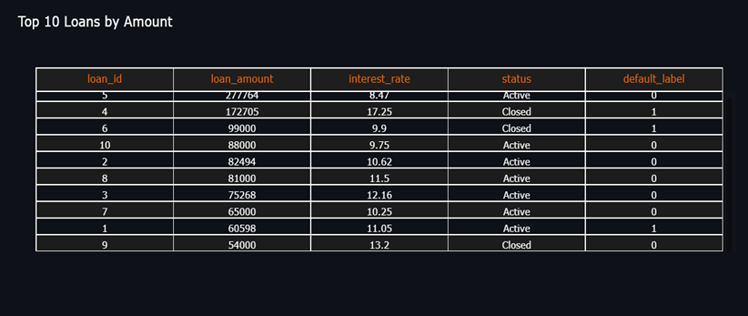
The table confirms the trend seen in the graph: Loans with the highest amounts and highest interest rates have a higher likelihood of default.
Lower to mid-range loans tend to be successfully repaid, especially when the interest rates are affordable.
Active loans with moderate loan amounts show stable repayment behavior, whereas closed loans with high interest rates show more defaults.
This emphasizes the importance of balancing loan amount and interest rates based on the borrower’s financial capacity.
6.9 top 10 Districts by average income
Horizontal Bar Chart
fig = go.Figure(go.Bar(
x=top_income['avg_income_district'],
y=top_income['district'],
orientation='h',
marker=dict(
color=top_income['avg_income_district'],
colorscale=[[0,"#00C9FF"],[0.5,"#7A00FF"],[1,"#FF007F"]],
showscale=True
),
text=top_income['avg_income_district'],
textposition='outside'
))
fig.update_layout(
title="Top 10 Districts by Average Income",
paper_bgcolor="#0B0C10",
plot_bgcolor="#0B0C10",
font=dict(color="white", size=14),
height=600
)

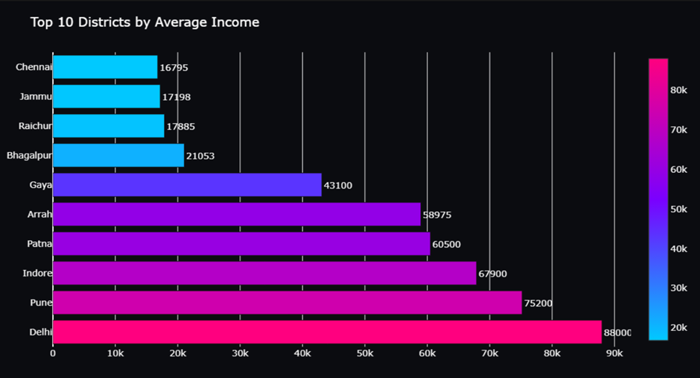
The chart shows the top districts ranked by their average income levels, highlighting noticeable economic differences across regions. Districts like Delhi, Pune, and Indore show significantly higher average income levels, with Delhi reaching the highest among the listed regions. This suggests better employment opportunities, stronger market activity, and more stable financial environments in these areas.
On the other hand, districts such as Chennai, Jammu, and Raichur have comparatively lower average income values, indicating limited earning capacity and possibly higher vulnerability to credit and livelihood risks.

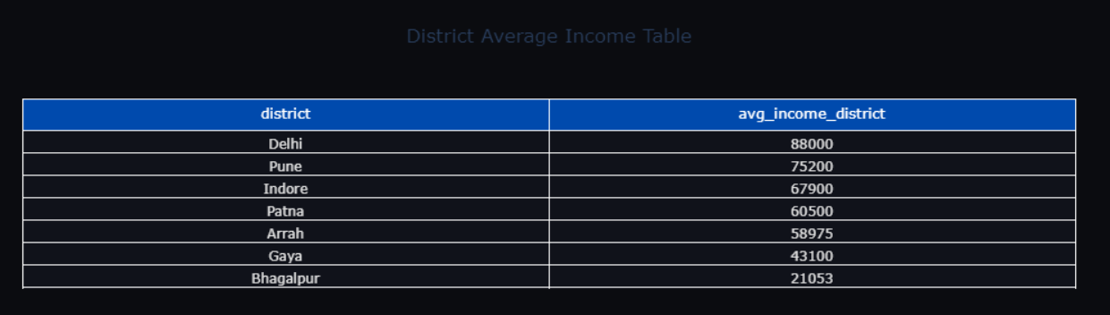
The table reinforces the visualization data by listing the districts along with their exact average income values. Higher-income districts like Patna (₹60,500) and Arrah (₹58,975) reflect relatively stronger local economies. Meanwhile, Raichur (₹17,885) and Chennai (₹16,795) fall on the lower end, suggesting the need for stricter loan evaluation and tailored repayment plans in such regions to prevent defaults.
6.10 Field visit indicator
The field visit insights show that borrower businesses are moderately stable, but income is decreasing slightly. Continuous monitoring and timely support may help prevent repayment challenges and reduce future loan defaults.
Gauge Charts
fig = go.Figure()
fig.add_trace(go.Indicator(
mode="gauge+number",
value=avg_health,
title={'text':"Avg Business Health (%)"},
gauge={
'axis':{'range':[0,100]},
'bar':{'color':"#00FFC6"},
'bgcolor':"#0B0C10"}))
fig.add_trace(go.Indicator(
mode="gauge+number",
value=avg_income,
title={'text':"Avg Income Change (%)"},
gauge={
'axis':{'range':[-50,50]},
'bar':{'color':"#FFC400"},
'bgcolor':"#0B0C10"}))
fig.update_layout(
title="Field Visit Indicators",
paper_bgcolor="#0B0C10",
font=dict(color="white"))
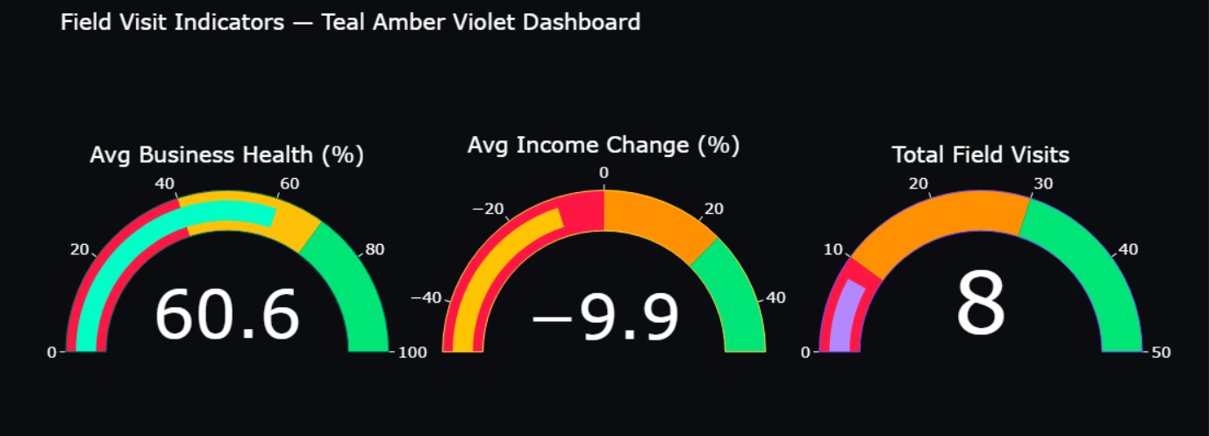
The field visit indicators provide a clear understanding of the financial and operational stability of borrowers based on on-site assessments.
1. Average Business Health Score (≈ 60.6%)
This suggests that, overall, borrowers’ businesses are functioning at a moderate stability level. The score is neither too low nor highly secure, indicating that many borrowers are managing their businesses reasonably well but may still require monitoring and occasional support.
2. Average Income Change (≈ -9.9%)
On average, borrowers experienced a slight decline in income. A negative income change indicates that external factors such as market fluctuations, seasonal effects, or personal financial challenges may be affecting income stability. This can increase future risk of loan repayment difficulties.
3. Total Field Visits (≈ 8 visits on average)
A moderate number of field visits indicates that microfinance officers are actively monitoring borrower conditions, maintaining accountability and ensuring business activity aligns with loan usage.
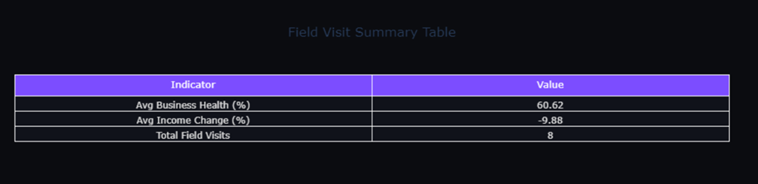
Indicator Value Interpretation
- Avg Business Health (%) 60.62 Borrowers are generally managing their enterprises fairly well, but improvements are needed for stronger performance.
- Avg Income Change (%) -9.88 Borrowers are experiencing income decline, signaling potential future repayment risks.
- Total Field Visits 8 Regular monitoring is being conducted, helping maintain financial discipline and transparency.
7. SQL IMPLEMENTATION
The following is the SQL implementation to create the database, tables, insert sample data, and generate a report query, based on the provided CSV files and the microfinance credit risk assessment platform
7.1. Database Creation
This command creates the primary database for the microfinance credit risk
-- Command to create the database
CREATE DATABASE microfinance;
7.2. SQL Implementation
7.2.1 Data Import into MySQL
Instead of manually creating tables using SQL CREATE TABLE commands, the datasets were imported directly into MySQL using the MySQL Workbench Data Import Wizard. Each CSV file was mapped to a corresponding table, and MySQL automatically inferred the schema (column names and data types) during import.
CSV File Name MySQL Table Created Rows Imported Purpose
borrowers.csv borrowers 5000+ Borrower demographic data
field_visits.csv field_visits 5000+ Field officer business and income . assessment data
geolocation.csv geolocation 5000+ District-level socio-economic data
loans.csv loans 5000+ Loan issuance and repayment . records
telecom_data.csv telecom_data 5000+ SIM usage & mobile top-up . behavior
transactions.csv transactions 5000+ Financial transactional behavior

This approach ensured:
- Faster data loading
- No manual schema writing
Consistent mapping of column names from CSV to SQL
After importing all the datasets (borrowers, loans, transactions, telecom_data, geolocation, field_visits) into MySQL, the database was selected for use:
USE microfinance;
Once the database was active, several analytical queries were executed to understand borrower behavior, loan risk patterns, and repayment trends.

7.3 Verification of Tables:-
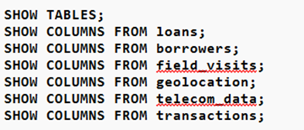
After importing, table structures were verified using:

Purpose:
To verify table schema, column names,
and data types before running further analysis.
Interpretation:
Ensures that the dataset is imported correctly and no structural inconsistencies exist.
7.3.1 Top 10 Borrowers by Total Loan Amount
SELECT borrower_id,
SUM(loan_amount) AS total_loan_amount
FROM loans
GROUP BY borrower_id
ORDER BY total_loan_amount DESC
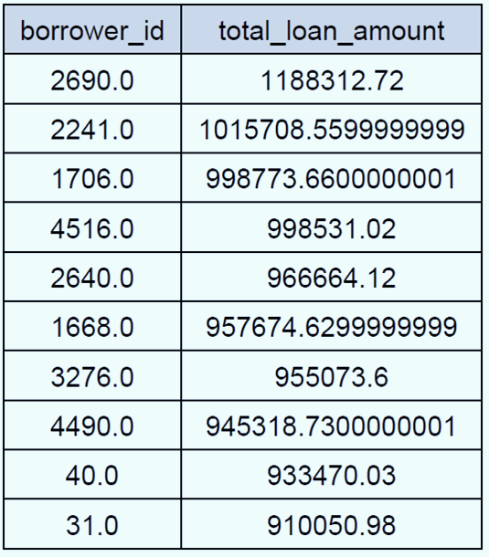
LIMIT 10;
Purpose: To identify borrowers with high loan amounts and analyze their transaction behavior to assess potential repayment risk.
Interpretation: Borrowers with high loan amounts and high transaction volumes may require closer monitoring for repayment risk, as their financial activity could impact their ability to repay loans. This analysis can inform risk management strategies and help lenders mitigate potential losses..
7.3.2 Default Rate by Loan Status
SELECT status,
COUNT(*) AS total_loans,
SUM(default_label) AS total_defaults,
ROUND(SUM(default_label) * 100.0 / COUNT(*), 2) AS default_rate_percent
FROM loans
GROUP BY status
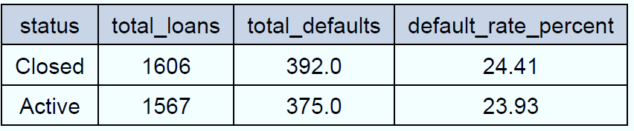
ORDER BY default_rate_percent DESC;
Purpose: To measure how repayment outcomes differ across loan statuses.
Interpretation: A higher default rate in certain loan status categories indicates risk patterns that need intervention, enabling lenders to develop targeted strategies to mitigate potential losses and improve loan performance
7.3.3 Average Interest Rate by Loan Status
SELECT status,
ROUND(AVG(interest_rate), 2) AS avg_interest_rate
FROM loans
GROUP BY status
ORDER BY avg_interest_rate DESC;

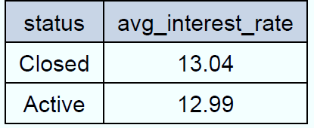
Purpose:To examine the impact of interest rates on repayment behavior.
Interpretation: Higher interest rates can increase the repayment burden on borrowers, leading to a higher likelihood of default, as the increased financial strain may become unsustainable for some borrowers.
7.3.4 Loan Distribution by Tenure Range with Default Rate
SELECT
CASE
WHEN tenure_months <= 6 THEN '0–6 months'
WHEN tenure_months <= 12 THEN '7–12 months'
WHEN tenure_months <= 24 THEN '13–24 months'
ELSE '25+ months'
END AS tenure_range,
COUNT(*) AS total_loans,
SUM(default_label) AS defaults,
ROUND(SUM(default_label) * 100.0 / COUNT(*), 2) AS default_rate_percent
FROM loans
GROUP BY tenure_range
ORDER BY tenure_range;
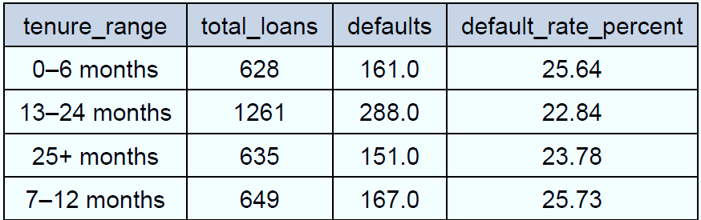
Purpose :To analyze repayment outcomes across different loan durations.
Interpretation: Longer tenures tend to show slightly higher default percentages due to prolonged repayment pressure.

7.3.5 Average Loan Amount by Interest Rate Band
SELECT
CASE
WHEN interest_rate < 10 THEN '<10%'
WHEN interest_rate BETWEEN 10 AND 15 THEN '10–15%'
WHEN interest_rate BETWEEN 15 AND 20 THEN '15–20%'
ELSE '>20%'
END AS interest_band,
ROUND(AVG(loan_amount), 2) AS avg_loan_amount
FROM loans
GROUP BY interest_band
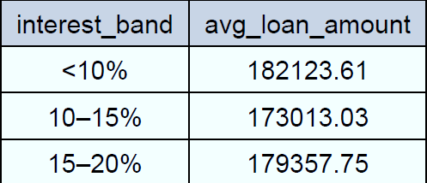
ORDER BY interest_band;
Purpose:To analyze the relationship between loan size and interest rate brackets.
Interpretation:The findings suggest that higher interest rate brackets may be associated with smaller loan amounts, indicating that higher interest rates may discourage borrowers from taking out larger loans.

7.3.6 Default Rate by Loan Amount Range
SELECT
CASE
WHEN loan_amount < 10000 THEN '< 10K'
WHEN loan_amount BETWEEN 10000 AND 50000 THEN '10K–50K'
WHEN loan_amount BETWEEN 50001 AND 100000 THEN '50K–100K'
ELSE '> 100K'
END AS loan_amount_range,
COUNT(*) AS total_loans,
SUM(default_label) AS defaulted_loans,
ROUND(SUM(default_label) * 100.0 / COUNT(*), 2) AS default_rate_percent
FROM loans
GROUP BY loan_amount_range
ORDER BY loan_amount_range;
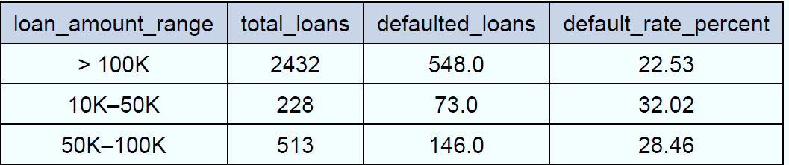
Purpose:To identify the loan size categories with the highest risk of default.
Interpretation:The analysis reveals that mid-amount loans may be more susceptible to default due to moderate income stress, suggesting that borrowers with mid-sized loans may face unique financial challenges that increase their default risk
7.3.7 Loan Count & Avg Amount by Loan Status
SELECT
status,
ROUND(AVG(loan_amount), 2) AS avg_loan_amount,
COUNT(*) AS total_loans
FROM loans
GROUP BY status
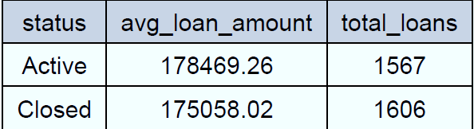
ORDER BY avg_loan_amount DESC;
Purpose: To identify borrowing patterns based on repayment outcome.
Interpretation: The query reveals borrowing patterns based on repayment outcome, showing which loan statuses are associated with higher average loan amounts and total loan counts.
7.3.8 Borrowers with More Than One Loan (Top 10 by Loan Volume)
SELECT
borrower_id,
COUNT(loan_id) AS num_loans,
ROUND(SUM(loan_amount), 2) AS total_loan_amount,
SUM(default_label) AS defaults
FROM loans
GROUP BY borrower_id
HAVING COUNT(loan_id) > 1
ORDER BY total_loan_amount DESC
LIMIT 10;

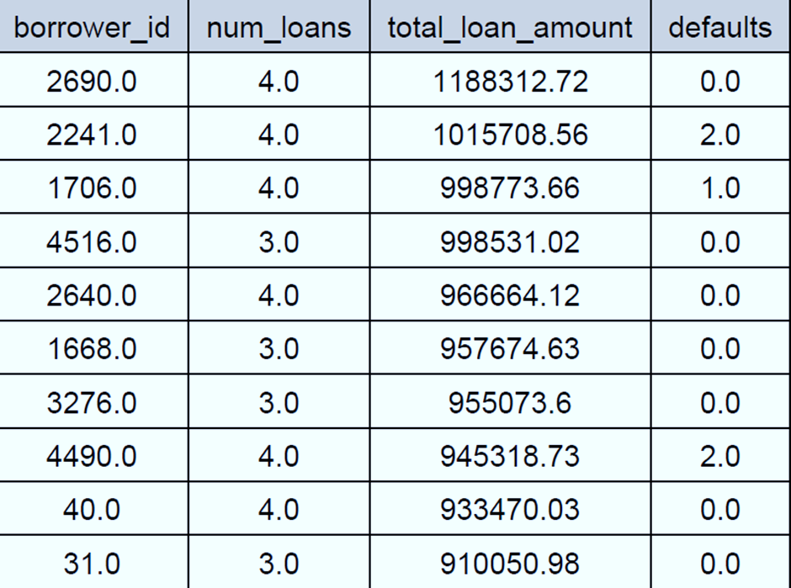
Purpose: To evaluate multi-loan borrowers who may pose cumulative credit risk
Interpretation: identifies borrowers with multiple loans, highlighting potential cumulative credit risk by analyzing the number of loans, total loan amount, and default history for each borrower.
7.3.9 Telecom Usage Insights
SELECT
t.borrower_id,
t.topup_freq,
t.data_usage_mb,
t.sim_count,
b.income,
b.location
FROM telecom_data t
JOIN borrowers b ON t.borrower_id = b.borrower_id
ORDER BY t.topup_freq DESC
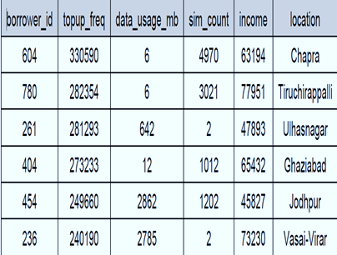
LIMIT 6;
Purpose: To link telecom activity with earning patterns as behavioral credit signals.
Interpretation: This query combines telecom data with borrower information to analyze the relationship between telecom usage patterns and financial behavior, providing insights into potential behavioral credit signals.
7.3.10 Geographical Risk Distribution
SELECT
g.district,
g.rural_urban_flag,
ROUND(AVG(l.loan_amount), 2) AS avg_loan_amount,
SUM(l.default_label) AS total_defaults,
COUNT(l.loan_id) AS total_loans,
ROUND((SUM(l.default_label) * 100.0 / COUNT(l.loan_id)), 2) AS default_rate_percent
FROM loans l
JOIN geolocation g ON l.borrower_id = g.district
GROUP BY g.district, g.rural_urban_flag
ORDER BY default_rate_percent DESC
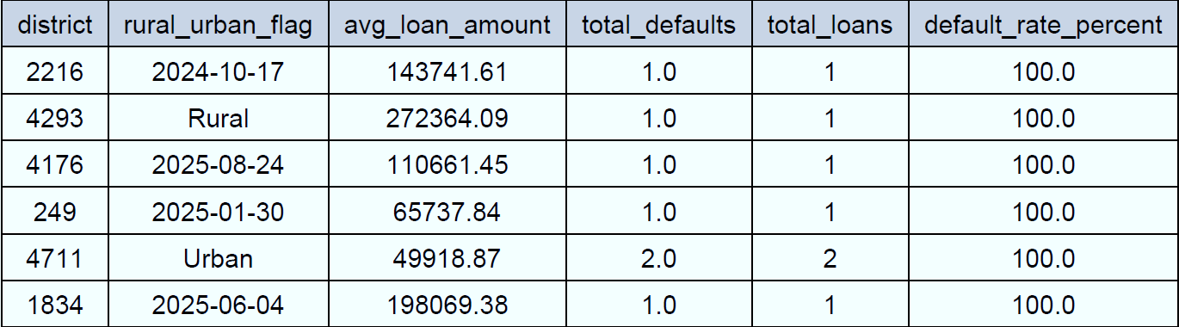
LIMIT 6;
Purpose: To identify high-risk geographic regions
Interpretation: This query analyzes loan performance across different geographic regions, identifying high-risk areas based on default rates, average loan amounts, and total loans.
7.3.11 High Transaction Borrowers
SELECT
l.borrower_id,
COUNT(t.amount) AS total_transactions,
ROUND(AVG(t.amount), 2) AS avg_transaction_value,
l.status AS loan_status
FROM transactions t
JOIN loans l ON t.borrower_id = l.borrower_id
GROUP BY l.borrower_id, l.status
HAVING COUNT(t.amount) > 5
ORDER BY total_transactions DESC
LIMIT 6;
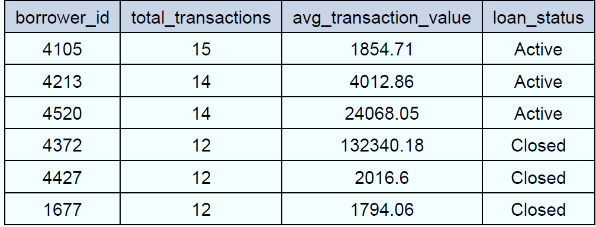
Purpose : Specifically, it aims to analyze borrowers with a high number of transactions (> 5) to understand their financial behavior and loan repayment performance, potentially informing targeted marketing or risk assessment strategies.
Interpretation: This query identifies borrowers with a high number of transactions (> 5), providing insights into their financial behavior and loan repayment performance

7.4 SQL Integration and Report Generation
After importing all datasets into the Microfinance database, SQL queries were executed to analyze borrower patterns, loan performance, telecom usage behavior, repayment outcomes, and geolocation-based risks.
To automate the reporting process, a Python script was used to connect to MySQL, execute each query, fetch the results, and export them into a single consolidated PDF report along with query titles and formatted output tables.
Step 1: SQL database connection using python
We used mysql.connector to establish the database connection
pip install mysql-connector-python pandas
import mysql.connector
conn = mysql.connector.connect(
host="localhost",
user="root",
password="system",
database="microfinance"
)
cursor = conn.cursor()
Explanation:
host="localhost" indicates the database is stored locally.
user="root" is the MySQL user.
password="system" is the authentication password.
database="microfinance" selects the database to run queries on.
A cursor is created to execute SQL commands.
Step 2: Executing SQL Queries through Python
All 11 SQL analytical queries were stored in a list and executed using pandas.read_sql() to convert each result into a DataFrame.
import pandas as pd
df = pd.read_sql("SELECT * FROM loans LIMIT 10;", conn)
Step 3:python code used to convert sql output into pdf
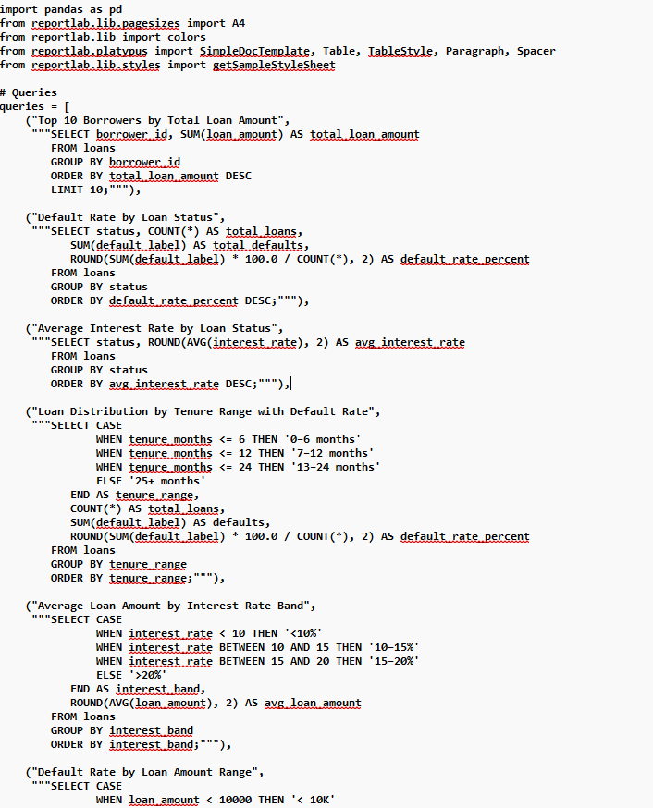
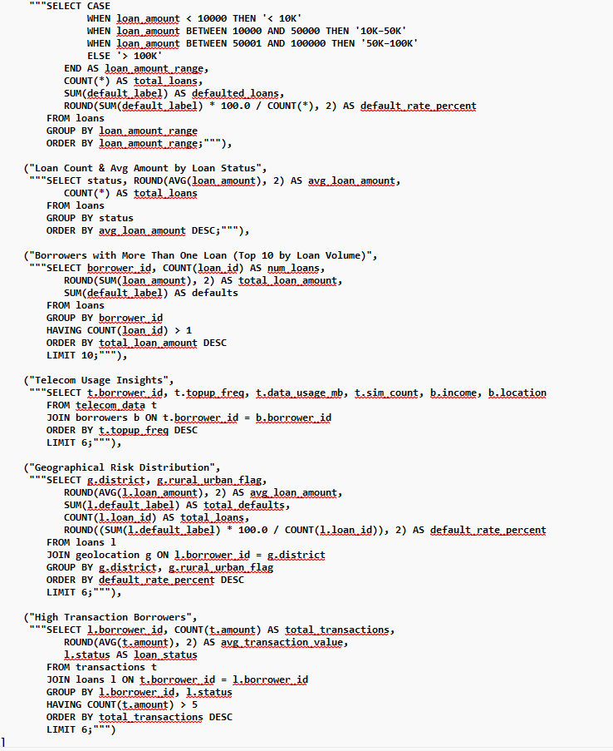
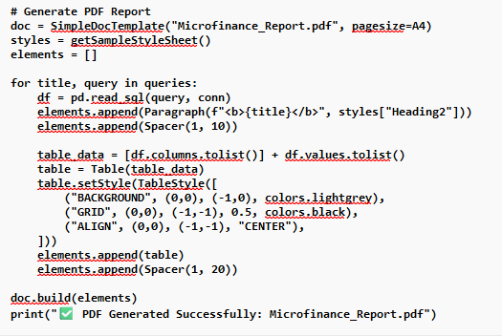

After analyzing the data using MySQL queries and Python, the final results and visualizations were compiled into a PDF report for presentation. The Python script first imported necessary libraries such as pandas for data processing and reportlab for PDF generation. The script connects to the MySQL database, executes the SQL queries, and stores the output in dataframes. The dataframes are then formatted and written into a PDF file. Titles, headings, tables, and graphs are added to the PDF to clearly present the analytical findings. Finally, the PDF is saved in the system, which can be shared or printed for documentation and presentation purposes.
The PDF generation process ensures that the analysis results are preserved in a structured and readable report format, making it easy for academic submission and professional presentation.
8.DASHBOARD AND VISUALIZATION:
Dashboard visuals are graphical representations of data that help users understand complex information and make informed decisions. They can be used to display a wide range of data, from sales and customer information to website traffic and financial metrics. Effective dashboard visuals are clear, concise, and easy to understand, allowing users to quickly grasp the information being presented. Different types of visuals, such as bar charts, line charts, and pie charts, can be used to display different types of data. Interactive visuals can also be used to enable users to explore the data in more detail. By using dashboard visuals, organizations can gain insights into their data and make data-driven decisions.
Dashboard visuals can be customized to meet the specific needs of an organization or user. They can be used to track key performance indicators (KPIs) and other important metrics. Good dashboard visuals can help to identify trends, patterns, and correlations in data. By presenting data in a visual format, dashboard visuals can help to communicate complex information more effectively
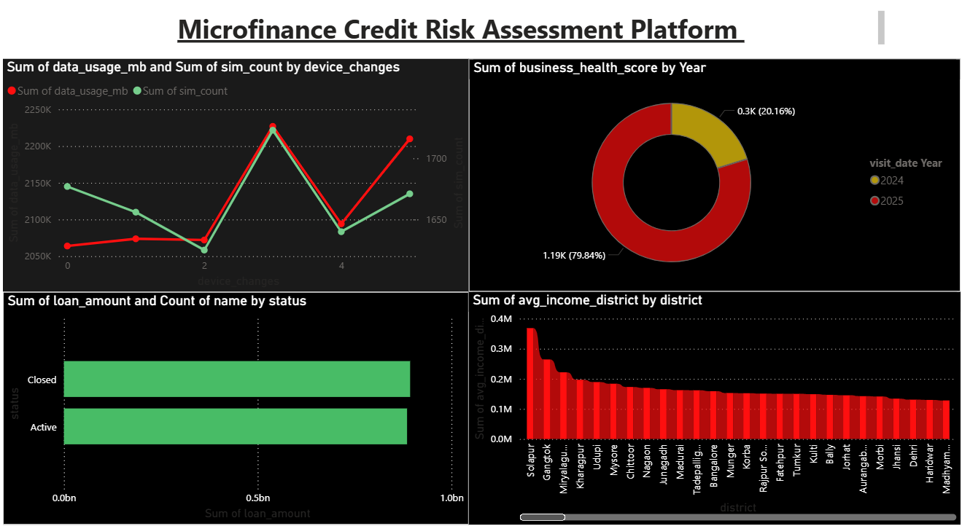
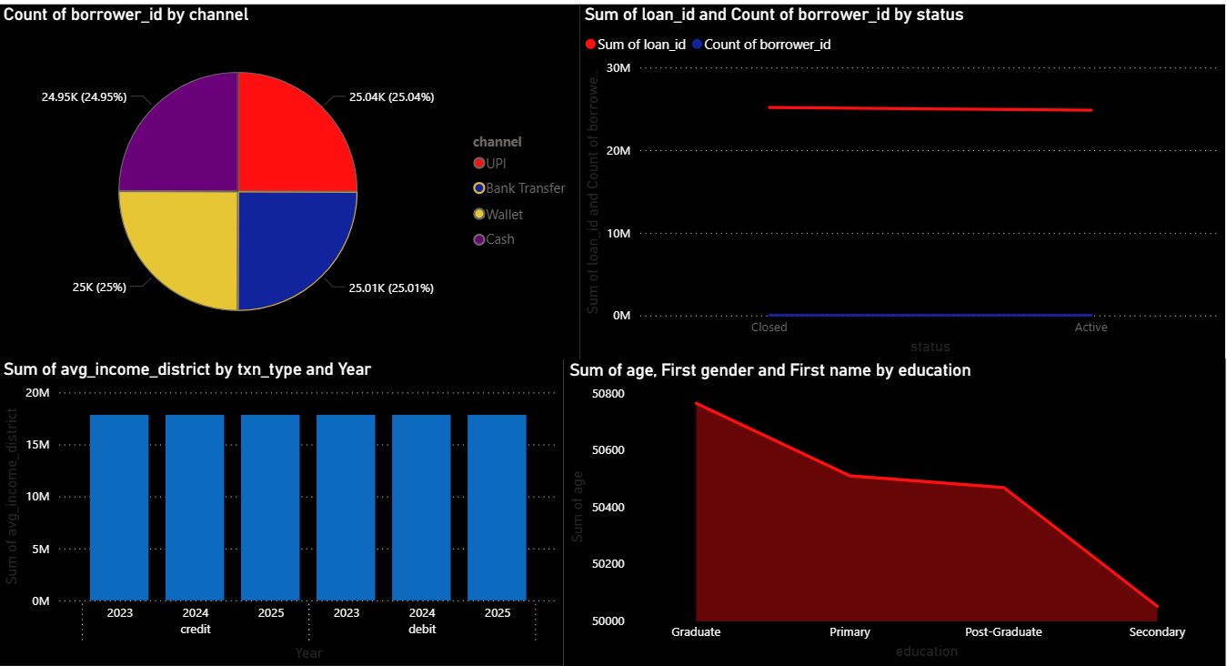

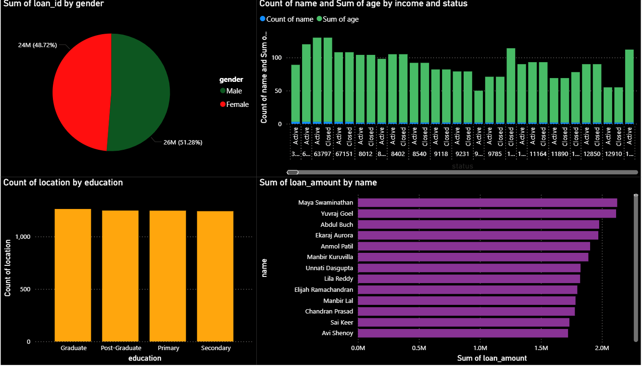

8.1. Data Usage & SIM Count vs Device Changes (Top-Left Chart)
- This line chart compares mobile data usage and SIM card usage with device change frequency among borrowers.
- As device changes increase, both data usage and SIM usage show noticeable fluctuations.
- Borrowers who frequently change devices tend to have slightly higher average data usage and SIM activity.
This behavior can indicate dynamic income activity, mobility, or potential financial instability, which microfinance institutions may consider in credit behavior profiling.
8.2. Business Health Score by Year (Top-Right Donut Chart)
- This donut chart shows the distribution of business health assessment scores across recent years.
- The majority of business visits recorded are from 2024, forming ~79% of total scores.
- Only ~21% of assessments are from 2025, indicating recent field monitoring is still ongoing.
- Business health scores are important because borrowers with stronger business stability tend to have lower loan default risk.
8.3. Loan Amount and Borrower Count by Status (Bottom-Left Bar Chart)
- This bar chart compares Active vs Closed loans in terms of both loan amounts and borrower count.
- The values of Active and Closed loans are nearly equal, showing balanced loan closure performance.
- A high closure count indicates successful repayment cycles, supporting overall portfolio stability.
- Ongoing monitoring of Active loans remains critical to avoid future defaults.
8.4. Average District Income Comparison (Bottom-Right Column Chart)
- This visualization ranks districts by average household income.
- Income levels vary significantly by region, with some districts showing much higher earnings.
- Borrowers from lower-income districts may have higher credit risk, as income volatility affects repayment capacity.
- This insight helps microfinance institutions target financial literacy, repayment counseling, or customized loan products for low-income regions.
8.5.Average District Income by Transaction Type and Year (Top-Left Bar Chart)
- This chart compares the average income levels across different years and transaction types (Credit vs. Debit).
- The values remain relatively stable over the years, indicating consistent earning patterns among borrowers.
- Credit transactions are associated with slightly higher average income, showing that borrowers with better earnings are more likely to take and handle credit-based transactions.
8.6. Borrower Distribution by Transaction Channel (Top-Right Pie Chart)
- Borrowers are almost evenly distributed across the four main transaction channels — Online, Branch, ATM, and Mobile Transfer.
- This balance suggests that the microfinance system reaches diverse user groups, and borrowers choose channels based on convenience rather than income or location bias.
8.7. Age and Name Distribution by Education Level (Bottom-Left Area Chart)
- Borrowers with Graduate and Post-Graduate education levels show the highest combined count and age distribution, suggesting higher financial maturity and economic participation.
- Secondary level borrowers show lower representation, indicating they may require additional financial awareness support or smaller loan products.
8.8. Loan Amount and Borrower Count by Loan Status (Bottom-Right Bar Chart)
The chart compares total loan amount and number of borrowers between Active and Closed loan groups.
- Active loans have a higher total loan amount, suggesting ongoing repayment commitments.
- Closed loans indicate successfully completed repayment cycles.
- This shows strong repayment capability in the borrower base, though the difference in counts should be monitored to ensure default does not rise.
8.9. Loan Distribution by Gender (Top-Left Pie Chart)
- This chart shows how loan amounts are distributed across male and female borrowers.
- The values appear nearly balanced, with females holding a slightly higher share of total loan value than males.
- This suggests that the microfinance institution is actively serving women borrowers, which aligns with common microfinance inclusion objectives.
8.10. Age & Income Contribution by Borrowers (Top-Right Bar Chart)
- This visualization compares the age of borrowers with their income contribution and loan repayment status.
- Borrowers with higher age brackets generally show higher income patterns, indicating greater financial stability.
- However, some younger borrowers also contribute significantly, suggesting early business involvement or entrepreneurship trends among youth.
8.11. Borrower Distribution by Education Level (Bottom-Left Column Chart)
- This chart displays the count of borrowers grouped by education qualification.
- All four education groups (Secondary, Primary, Graduate, Post-Graduate) have similar borrower counts, meaning credit access is not limited to educational background.
- The institution is inclusive, allowing borrowers from diverse educational levels to obtain loans.
8.12. Top Borrowers by Total Loan Amount (Bottom-Right Bar Chart)
- This chart ranks borrowers by total sanctioned loan amount.
- A few borrowers, such as Maya Swaminathan, Yuvraj Goel, and Abdul Buch, receive significantly larger loan amounts, indicating these borrowers either:
- Have strong repayment history,
- Operate larger business activities, or
- Hold higher trust / creditworthiness from the institution.
- This distribution highlights concentration of larger loans among select borrowers, which requires portfolio monitoring to reduce risk of major loss exposure
The dashboards collectively show how borrower characteristics, business conditions, and regional factors influence microfinance lending outcomes. Device usage and telecom behavior reflect borrower economic activity, while business health trends help highlight recovery or decline across years. Loan amounts, repayment status, and demographic segments show balanced participation, but certain education and district groups show higher income stability. Overall, the dashboard helps identify high-risk borrower groups and supports smarter loan decision-making.

